EXPERIMENT 5:
ARDUINO BASED MANUAL ELECTRONIC COUNTER USING PROTEUS

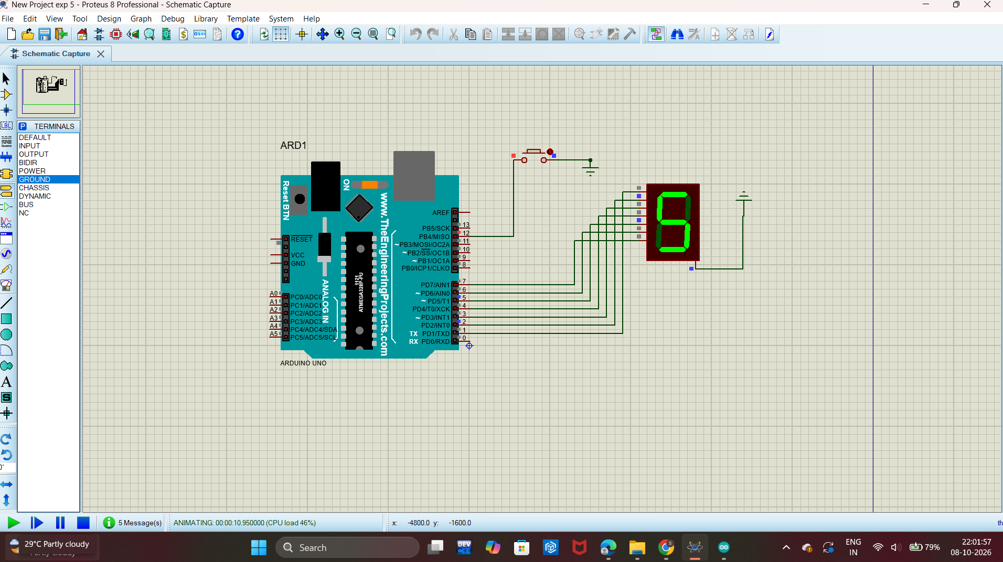

PROGRAM:
// Arduino UNO + 7 Segment + Push Button
// Proteus circuit
// Common Cathode 7-Segment

int a = 1;
int b = 2;
int c = 3;
int d = 4;
int e = 5;
int f = 6;
int g = 7;

int button = 12;

int count = 0;

void setup()
{
pinMode(a, OUTPUT);
pinMode(b, OUTPUT);
pinMode(c, OUTPUT);
pinMode(d, OUTPUT);
pinMode(e, OUTPUT);
pinMode(f, OUTPUT);
pinMode(g, OUTPUT);

pinMode(button, INPUT_PULLUP);

displayNumber(count);
}

void loop()
{
if (digitalRead(button) == LOW)
{
count++;

if (count > 9)
{
count = 0;
}

displayNumber(count);

delay(300);
}
}

void displayNumber(int n)
{
switch(n)
{
case 0:
digitalWrite(a,HIGH);
digitalWrite(b,HIGH);
digitalWrite(c,HIGH);
digitalWrite(d,HIGH);
digitalWrite(e,HIGH);
digitalWrite(f,HIGH);
digitalWrite(g,LOW);
break;

case 1:
digitalWrite(a,LOW);
digitalWrite(b,HIGH);
digitalWrite(c,HIGH);
digitalWrite(d,LOW);
digitalWrite(e,LOW);
digitalWrite(f,LOW);
digitalWrite(g,LOW);
break;

case 2:
digitalWrite(a,HIGH);
digitalWrite(b,HIGH);
digitalWrite(c,LOW);
digitalWrite(d,HIGH);
digitalWrite(e,HIGH);
digitalWrite(f,LOW);
digitalWrite(g,HIGH);
break;

case 3:
digitalWrite(a,HIGH);
digitalWrite(b,HIGH);
digitalWrite(c,HIGH);
digitalWrite(d,HIGH);
digitalWrite(e,LOW);
digitalWrite(f,LOW);
digitalWrite(g,HIGH);
break;

case 4:
digitalWrite(a,LOW);
digitalWrite(b,HIGH);
digitalWrite(c,HIGH);
digitalWrite(d,LOW);
digitalWrite(e,LOW);
digitalWrite(f,HIGH);
digitalWrite(g,HIGH);
break;

case 5:
digitalWrite(a,HIGH);
digitalWrite(b,LOW);
digitalWrite(c,HIGH);
digitalWrite(d,HIGH);
digitalWrite(e,LOW);
digitalWrite(f,HIGH);
digitalWrite(g,HIGH);
break;

case 6:
digitalWrite(a,HIGH);
digitalWrite(b,LOW);
digitalWrite(c,HIGH);
digitalWrite(d,HIGH);
digitalWrite(e,HIGH);
digitalWrite(f,HIGH);
digitalWrite(g,HIGH);
break;

case 7:
digitalWrite(a,HIGH);
digitalWrite(b,HIGH);
digitalWrite(c,HIGH);
digitalWrite(d,LOW);
digitalWrite(e,LOW);
digitalWrite(f,LOW);
digitalWrite(g,LOW);
break;

case 8:
digitalWrite(a,HIGH);
digitalWrite(b,HIGH);
digitalWrite(c,HIGH);
digitalWrite(d,HIGH);
digitalWrite(e,HIGH);
digitalWrite(f,HIGH);
digitalWrite(g,HIGH);
break;

case 9:
digitalWrite(a,HIGH);
digitalWrite(b,HIGH);
digitalWrite(c,HIGH);
digitalWrite(d,HIGH);
digitalWrite(e,LOW);
digitalWrite(f,HIGH);
digitalWrite(g,HIGH);
break;
}
}

